Workout # 1

Strength Exercises
Push Ups | 2 X As many as you can do
Overhead Squats | 2 X 15
Spiderman | 2 X 16
Mountain Climbers | 2 X 16
Side Plank | 1 time each side as long as you can hold

Plyometric Exercises
Line Jumps | 2 X 20
Tuck Jumps | 2 X 10

Workout # 2

Strength Exercises
Burpees | 2 X 10
Pull Ups | 2 X As many as you can do
Lunges | 2 X 20
Crunches | 2 X 20
Leg Raises | 2 X As long as you can hold

Plyometric Exercises
Ankle Hops (Bunny Hops) | 2 X 20
Squat Jumps | 2 X 10

*Provide yourself plenty of time to rest between plyometric exercises. We are focused on quality and not quantity.
*Adjust the reps of each exercise based on your own individual ability. This program is an outline so you have some direction for workouts you can do at home.

Workout #1

Spiderman

The Spiderman Mountain Climber is a variation where you bring your foot as close to your hand and plant it flat on the ground. This movement will require lots of mobility in your hip. Keep working to move your foot as close as possible to your hand on each repetition. The ideal form is to plant your foot flat on the ground next to your hand so your shin is parallel with your arm and vertical to the ground.

Line Jumps
Simply jump side to side over a line as fast as you can.

Tuck Jumps

Jump up in the air and bring your knees to your chest. As soon as you land, explode up into your next jump.
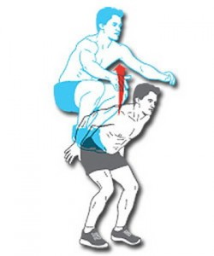

Workout # 2

Burpees

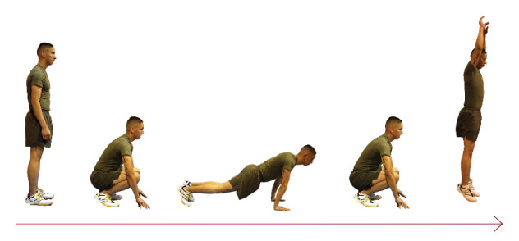
Ankle Hops
Standing nice and tall, you jump up utilizing your feet and ankles to push off from the ground. Immediately upon landing, jump up again. During the duration of the exercise, try not to bend your knees.
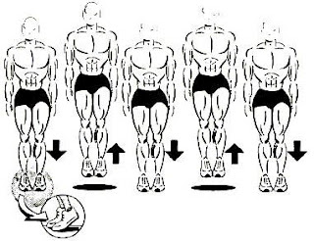
Squat Jumps

Squat down and explode upward into a jump. As you land, go right into your next squat and immediately jump up as high as you can again.

